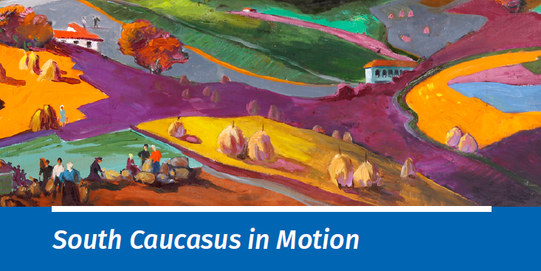
Book Launch
May 8th, 2019, 15:00-16:30
International School of Economics in Tbilisi (ISET)
16, Zandukeli Street

15:00 – Opening remarks by Mercy Tembon, the World Bank Regional Director for the South Caucasus
15:10 – Remarks by Tamar Sulukhia, Director, ISET and ISET Policy institute
15:15 – “South Caucasus in Motion” book launch in Tbilisi
15:15-16:00 – Presentation by Alan Fuchs and Cesar Cancho, the World Bank
16:00-16:30 – Q&A session
16:30:16:45 – Media opportunity

